fall 2024
Cse-4355/5355 Electromechanical Systems and Sensors
the university of texas at arlington


lab 5 report
Submitted toward the partial completion of the requirements for CSE 4355/5355
Under the guidance of
Prof. Jason Losh
By:
Dario Ugalde, 1001268068
Joshua Martinez, 1001374818

Introduction
This lab will explore capturing two different real-time measurement methods. The main functionality behind these methods are the frequency and timer systems within the TM4C microcontroller. The timer method is accompanied by the built-in comparator functions with the red board and are used to find the basis of the water level within a container. The next method measures the amount of metal within an external wire coil which is translated into a frequency. This lab demonstrates how timers and comparators help achieve real-time measurements without the need of physically interacting or understanding with the objects they are measuring.

Water Level Measurement
The first part of this lab revolves around creating a circuit that measures a container’s liquid level. Electrodes are attached parallel along the height of the container and a few millimeters apart. This will create a sort of capacitor that will increase/decrease the capacitance it has based on the water level. If the water level in the bottle is high, the two electrodes will have a better connection and ‘charge’ more when compared to when there’s less liquid in it. The main part of the circuit is as follows: the 3.3 voltage source, a 100k ohm resistor, the electrodes, and the ground. To be able to measure the capacitance capabilities of the bottle, a transistor’s collector and emitter is used on either side of the electrodes. The gate will be connected to a GPO pin on the microcontroller, giving a method of powering the transistor between off and on. During usage, the transistor will short the voltage source to ground allowing the capacitor to lose all its stored energy. Once the transistor is turned off, current will flow through the bottle once again and charging it. This setup allows a controllable charge and drain of the bottle capacitor. Figure 1 below demonstrates this constant state changing on an oscilloscope. As mentioned earlier, the bottle receives more energy the more liquid it contains when energized. This is where a comparator comes into play.
A comparator’s output is based on two connections (positive and negative) which it receives. It uses a voltage reference point to assert its output which is based upon the positive voltage against the negative one. The TM4C has two comparators built in which outputs zero once the negative connection surpasses the positive end, else the output is one. We utilized the second comparator with the following configurations: the positive end uses the 3.3V on-board voltage source, pin PF1 has its functionality changed to comparator 1s output, and the Vref limit is set to 2.469V. The comparator’s negative end was wired to the positive end of the bottle’s electrodes to measure its voltage. Thus, when the bottle’s capacitance charges up to the Vref, the comparator’s output will change. To properly measure the different times of the bottle based on its liquid level, a timer is required. Our code basis is from a frequency/timer code file the professor shared with his students. This setup can be seen in Figure 2 below.
We added code which configured the necessary comparator as listed above. A function was also created to turn the transistor on for a brief period, then off once again. The corresponding timer will be set to zero and have the time limit saved once the comparator’s output becomes zero. The amount of time it takes for the comparator to change outputs is linearly based on the bottle’s liquid level. By empirically measuring the time vs the amount of liquid, we derived a function to convert the captured time to approximately determine the amount of liquid in the container around a 30-point range. Figure 3 illustrates the working conversion on a puTTY terminal with ~750 mL in the bottle.
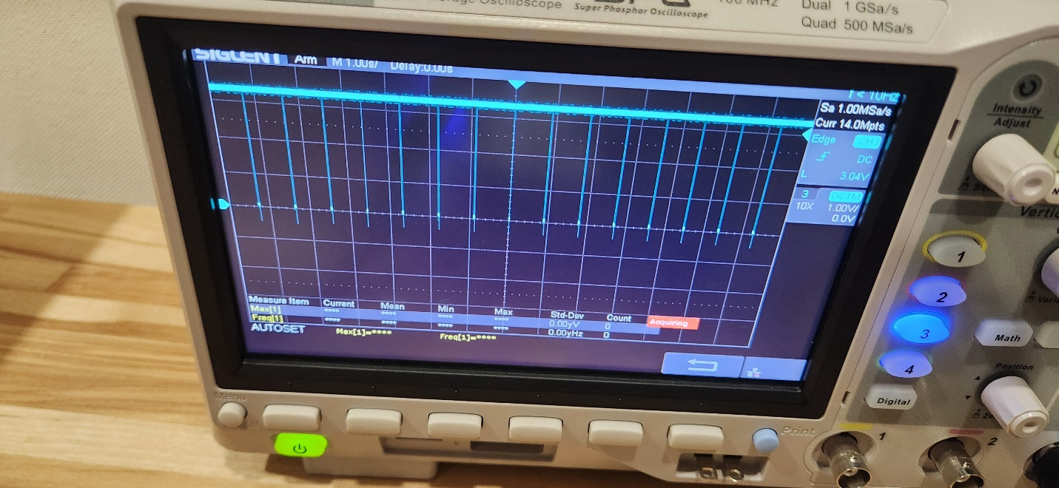
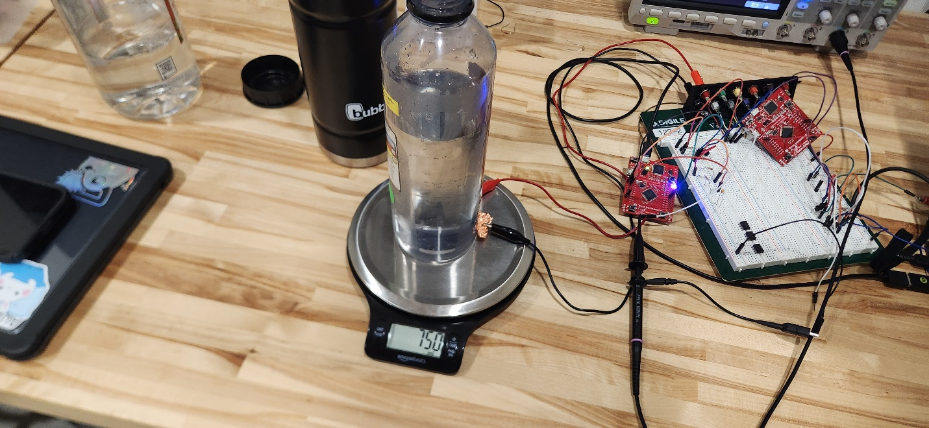
Figure 1: Water bottle Capacitance during demo

Figure 2: Setup used during demo

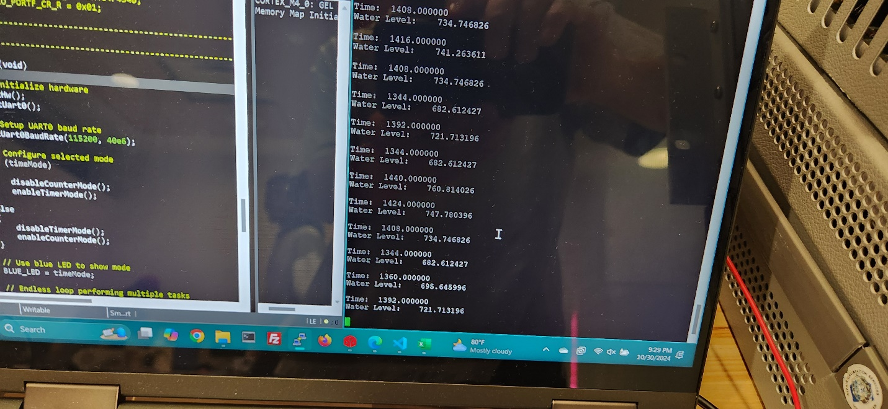
Figure 3: puTTY output with about 750 mL in capacitive bottle

Metal Detector
For the second half of the lab, we configured a simple Colpitts oscillator circuit to drive a frequency signal into the wire coil. This circuit was powered by the TM4C red board’s 5V pin. This allows the wire coil to behave as an inductor as the current flows. Placing metals within the coil affected the frequency of the circuit, effectively creating a simple metal detector. On the TM4C red board, we recycled the freq_time.c code to connect the CCP counter module that allowed us to read the frequency of the circuit. By placing different amounts of metal objects in the coil, the frequency counter increased within specific and different ranges based on them. Figure 4 below demonstrates the squared frequency used to measure the ranges during testing. In our case, we measured the change in frequency by using the following metal-containing objects: a large aluminum water bottle, a weight scale, and a metal stool. Our idle frequency was in the range of 87500Hz – 88000Hz while the bottle, scale, and stool fell in the following ranges, respectively: 89300Hz – 89500Hz, 91,000Hz – 93,000Hz, and 139,500Hz – 147,500Hz. Figures 5 through 7 show these objects’ placement during testing. The code was modified to flash color LEDs when these specific ranges were encountered along with a UART message of what the object was believed to be. As this metal detecting circuit is limited in its abilities, the objects we selected were chosen to not have overlapping ranges as differentiating them would be difficult.
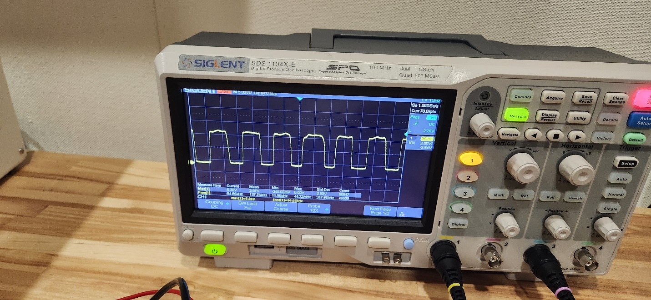
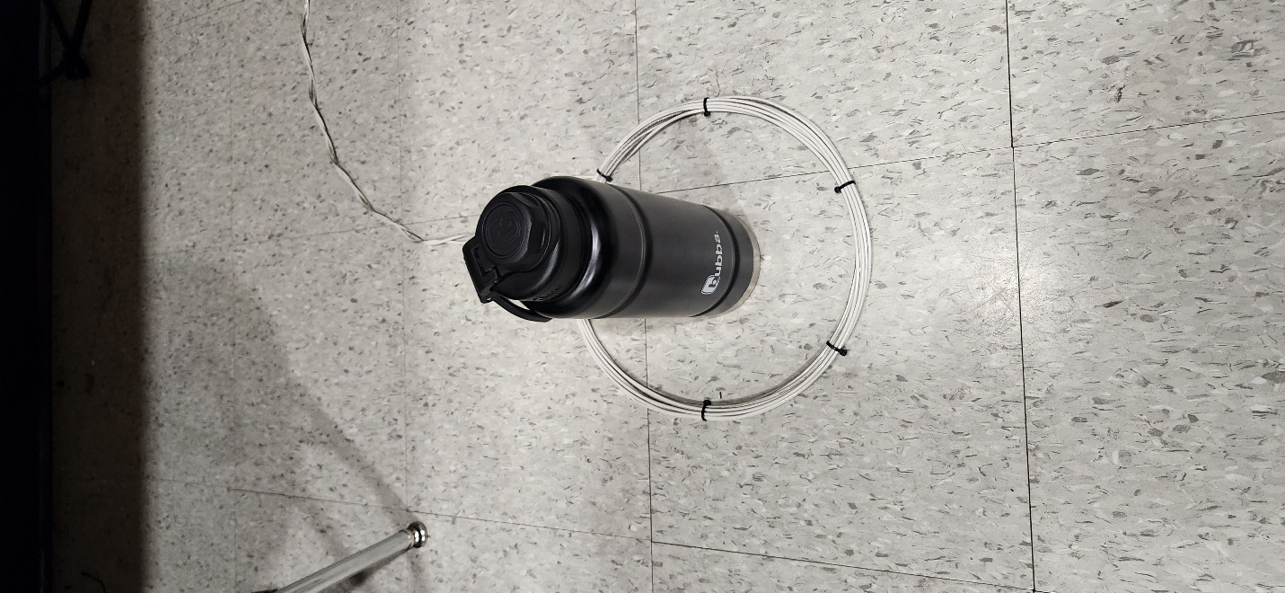
Figure 4: Metal detector’s oscilloscope wave during testing

Figure 5: Aluminum bottle during testing

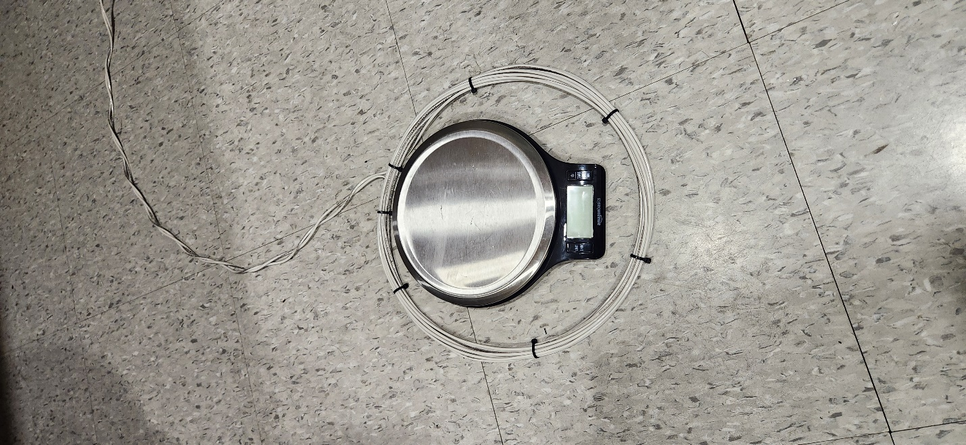
Figure 6: Weight scale used during testing
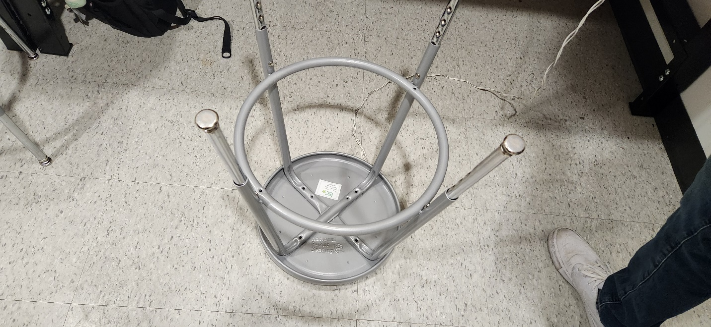

Figure 7: Metal stool used during testing

Conclusion
With this lab, we explored how the TM4C microcontroller can be used to capture difficult measurements such as water levels and metal detection. In the first part of this lab, the water level section operated through a comparator output based on the capacitive of the water bottle which correlates to it’s amount of liquid. Through the use of a timer and temporary discharging, we captured values that we empirically translated to identify water levels. The second part of the lab dealt with a metal detection system. Based on the frequency change with the presence of our select objects, we created ranges meant to identify our select objects and their unique signatures. Overall, this lab provided experience with two methods of material identifaction, which are capacitence and frequency differences.

Final Setup

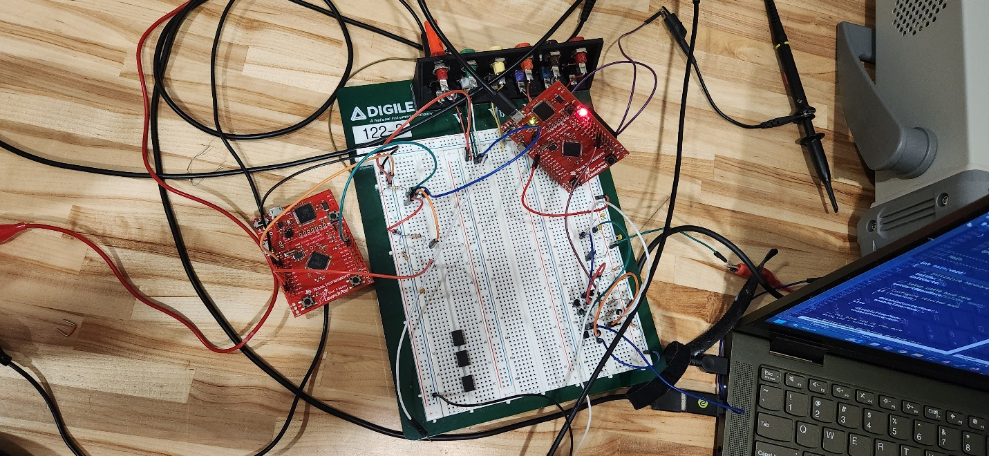

Figure 8: Final setup for whole lab demo

